Optimizing Recruitment: Harnessing Machine Learning for Predictive Hiring Decisions

kmecmiemcjv

*Abstract*— This study investigates the application of machine learning models to optimize recruitment processes by predicting hiring decisions based on candidate profiles. The goal is to develop a predictive model that classifies candidates as “hired” or “not hired” using demographic data, qualifications, and recruitment scores. A dataset of 1,500 candidates was used, incorporating features such as age, gender, education level, work experience, and skill scores. Several machine learning algorithms, including Random Forest, Support Vector Machine, Logistic Regression, and ensemble methods (CatBoost, XGBoost), were evaluated to determine the best-performing model and identify the most influential features. Results show that CatBoost outperformed other models, achieving an accuracy of 95%, followed by Random Forest and XGBoost. Analysis of feature importance revealed that Recruitment Strategy, Education Level, and Personality Score were the top three factors influencing hiring decisions. These findings suggest that machine learning can enhance recruitment efficiency, reduce biases, and improve hiring outcomes.

Keywords—Machine Learning, Predictive Hiring, Recruitment, Hyperparameter Tuning, Classification, HR & Modelling

# Introduction

The hiring process is crucial to an organization's success, as it determines the talent aligned with its strategic goals. However, traditional recruitment methods, including manual screening and interviews, are often time-consuming, resource-intensive, and prone to biases. These biases can lead to suboptimal hiring decisions, affecting diversity and organizational growth. As a result, there has been growing interest in leveraging machine learning (ML) models to improve recruitment efficiency, reduce biases, and enhance decision-making [1]. Despite their potential, existing predictive models in hiring face significant challenges, particularly in mitigating fairness issues.

## Problem Statement

Although ML models have shown promise in improving recruitment accuracy, they are susceptible to issues like dataset imbalance, which can exacerbate biases in hiring predictions. For example, an imbalanced dataset where one gender or educational group predominates can lead to biased predictions favoring the overrepresented group, perpetuating existing disparities [2]. While existing studies have examined ensemble methods like CatBoost and XGBoost, this paper seeks to demonstrate their superiority over simpler models by highlighting their enhanced predictive performance and practical value in optimizing hiring decisions [3] [4] [5]. These models have demonstrated robust performance in handling imbalanced datasets and capturing complex, non-linear relationships, yet their application in recruitment prediction is underexplored [6].

## Objective

This research aims to develop a predictive model to improve the accuracy and fairness of hiring decisions by addressing bias-related challenges in the recruitment process. It evaluates the performance of advanced ensemble models like CatBoost and XGBoost against traditional models such as Random Forest and Logistic Regression. These advanced models are chosen for their ability to handle imbalanced datasets and capture intricate patterns in candidate data [7].

## Significance

This research contributes to the academic discourse on machine learning in recruitment by advancing the understanding of how predictive models can optimize hiring decisions while mitigating biases. The study builds on existing literature by demonstrating the superiority of ensemble models, particularly CatBoost, in handling imbalanced datasets and capturing complex non-linear relationships.

By systematically evaluating machine learning techniques in hiring processes, this research highlights the role of Artificial Intelligence (AI) - driven models in enhancing decision-making, reducing human biases, and improving recruitment efficiency. It also addresses critical challenges such as fairness, transparency, and ethical considerations in AI-based hiring, contributing to the broader discussion on responsible AI adoption in human resource management.

Furthermore, this study sets a benchmark for future research by integrating hyperparameter tuning, feature importance analysis, and cross-validation techniques to ensure robustness and generalizability. The findings offer practical implications for both academic and industry, providing data-driven insights that can inform HR strategies and improve hiring outcomes. By bridging theoretical advancements with real-world applications, this research paves the way for future innovations in AI-powered recruitment systems.

## Research Question

The central research question guiding this study is: **Which features are most predictive of hiring decisions, and how can machine learning models be leveraged to optimize recruitment strategies while mitigating bias?** To answer this, we examine features such as education, skill scores, and work experience, with the aim of developing models that support automated, efficient, and fair hiring processes.

## Literature Review

The application of machine learning in recruitment has garnered significant attention in recent years as organizations aim to enhance hiring efficiency and reduce biases. Studies have shown that AI-driven solutions can automate repetitive tasks, improve candidate screening, and promote diversity in hiring practices. Tasheva and Karpovich (2024) highlight that AI advancements, including machine learning, natural language processing, and big data analytics, are transforming recruitment workflows across industries [8]. However, they also emphasize the need to maintain a human touch in these processes to preserve values like empathy and cultural fit, which AI struggles to replicate.

Peña et al. explored the challenges of bias in AI-driven recruitment systems, proposing a multimodal framework that combines structured data, image analysis (using ResNet-50), and text data (using BiLSTM models) to mitigate inherent algorithmic biases [9]. They underscore the importance of diverse, inclusive training datasets and advocate for fairness-aware methods to ensure transparency and equity in decision-making. Similarly, Tasheva and Karpovich draw attention to ethical concerns such as data privacy and algorithmic fairness, suggesting strategies like anonymization and rigorous testing for bias to address these issues.

In addition to addressing bias, AI has demonstrated measurable improvements in recruitment metrics. Tasheva provide examples of organizations achieving significant gains through AI integration. For instance, Unilever reduced its hiring cycle by 80% using AI tools, while Costa Coffee cut hiring costs by 60% through chatbot-enabled screening. These cases validate the return on investment (ROI) of AI in streamlining high-volume recruitment processes [8].

Al-Quhfa et al. (2024) conducted a comparative analysis of machine learning models in talent recruitment within business intelligence systems, identifying ensemble methods and neural networks as superior approaches [9]. Their study revealed that models such as Random Forest and Neural Networks excel in handling imbalanced datasets, achieving accuracy rates exceeding 92%. These findings reinforce the potential of advanced algorithms in improving both efficiency and fairness in recruitment.

While prior research in recruitment prediction has largely relied on traditional algorithms such as Logistic Regression and Support Vector Machines, this study pioneers a more advanced approach by integrating ensemble models with K-Fold Cross-Validation. K-Fold Cross-Validation is a resampling method that splits the dataset into K subsets, training the model on K-1 subsets and validating it on the remaining one in a repeated cycle. This approach enhances model generalizability and stability by preventing overfitting and ensuring all data points are used for both training and validation (Breiman, 2001). In addressing dataset imbalance, K-Fold Cross-Validation ensures representative subsets, reducing bias and improving predictive accuracy. By capturing complex, non-linear relationships among candidate features, these models mitigate biases inherent in conventional methods, advancing fairness in AI-driven hiring. Through empirical evaluation, we demonstrate the superior performance of this ensemble-based framework, offering actionable insights for researchers and practitioners. This study sets a new benchmark for ethical and accurate AI applications in recruitment, paving the way for future innovations in predictive hiring.

# methodologies

## Dataset Summary

The dataset used in this study consists of 1,500 candidates and 11 features, capturing various candidate attributes including age, gender, education level, work experience, and skill scores. The target variable, Hiring Decision, indicates whether a candidate was hired (1) or not hired (0). A summary of the key features in the dataset is provided in Table 1.

1. summary of the features in the dataset

|  |  |  |
| --- | --- | --- |
| **Feature** | **Description** | **Data Type** |
| Age | Age of the Candidate | Numerical |
| Gender | 0: Male, 1: Female | Categorical |
| Education Level | 1: Bachelor’s (Type 1), 2: Bachelor’s (Type 2), 3: Master’s, 4: PhD | Categorical |
| Experience Years | Number of years of professional experience | Numerical |
| Interview Score | Score achieved by the candidate in the interview process | Numerical |
| Skill Score | Assessment score of candidate’s technical skills | Numerical |
| Personality Score | Evaluation score of the candidate’s personality traits | Numerical |
| Recruitment Strategy | 1: Aggressive, 2: Moderate, 3: Conservative | Categorical |
| Hiring Decision | 0: Not Hired, 1: Hired | Categorical |

## Preprocessing Steps

### Converting Numerical Variables to Categorical

In the preprocessing phase, some variables with discrete, limited values were recast as categorical variables to enhance model interpretability. For example, Gender, Education Level, and Recruitment Strategy were originally represented numerically (e.g., 0 for male, 1 for female) and were redefined as categorical labels for clearer classification during model training. This conversion helps improve the model's ability to distinguish between categories effectively and allows for better handling by certain machine learning algorithms.

### Handling Missing Values, Duplicate Rows, Feature Scaling & K-Fold Cross-Validation

Initial data exploration revealed no missing values or duplicate entries in the dataset, ensuring the integrity of the dataset. Therefore, no imputation or duplicate removal was necessary. Given the lack of missing or redundant data, feature scaling was also not applied as the variables in the dataset were either categorical or already on comparable scales (e.g., skill scores and experience years). Feature scaling may be required for models like Support Vector Machines (SVM) or k-Nearest Neighbors (k-NN) if those models were used. However, to ensure the robustness and generalizability of our models, we employed K-Fold Cross-Validation with K=30. Given the dataset of 1,500 candidates, using 30 folds ensured that each validation set contained approximately 50 data points, maintaining a balance between training and validation splits without losing too much training data. A larger K value helps reduce variance by creating smaller validation sets, leading to a more reliable estimate of model performance across different data subsets. By choosing K=30, we minimized the impact of outliers and enhanced the model’s ability to generalize effectively.

### Summary Statistics

Table 2 presents a summary of the key statistics for the candidates' demographic and performance metrics. The mean age of participants is 35.15 years, with a standard deviation (SD) of 9.25 years, indicating moderate variation in age among respondents. The median age is 35 years, closely aligned with the mean, suggesting a fairly symmetrical distribution. The mode is 45 years, indicating that this was the most frequently occurring age in the dataset. The minimum age recorded is 20 years, while the maximum is 50 years.

For work experience, the mean is 7.69 years, with an SD of 4.64 years, showing some variability in the dataset. The median experience is 8 years, indicating that candidates tend to have senior-level experience. The mode is 15 years, the most common value recorded. The candidates’ years of experience ranges from 0 to 15 years.

The interview scores have a mean of 50.56, with a high SD of 28.62, reflecting considerable variability in candidate performance. The median score is 52, slightly above the mean, and the mode is 72, indicating that this score appeared most frequently. Scores range from 0 to 100, representing the full spectrum of possible outcomes.

Similarly, the skill scores have a mean of 51.12 and an SD of 29.35, highlighting a broad distribution. The median score is 53, and the mode is 79, suggesting that this value was the most observed. The minimum and maximum skill scores are 0 and 100, respectively.

The personality scores have a mean of 49.38 and a standard deviation (SD) of 29.35, closely resembling the distribution pattern of skill scores. The median score is 49, and the mode is 43, indicating that 43 was the most frequently observed score. The range ranges from 0 to100, demonstrating wide variability in personality assessments.

These statistics highlight variability across all variables, particularly in interview, skill, and personality scores, where standard deviations are relatively high. The presence of minimum values at zero suggests some participants scored poorly in these categories, whereas others achieved perfect scores, indicating diverse performance levels among respondents.

1. summary statistics of key variables

|  |  |  |  |  |  |
| --- | --- | --- | --- | --- | --- |
| **Statistics** | **Age (years)** | **Experience Years** | **Interview Scores** | **Skill Score** | **Personality Score** |
| **Mean** | 35.15 | 7.69 | 50.56 | 51.12 | 49.38 |
| **SD** | 9.25 | 4.64 | 28.62 | 29.35 | 29.35 |
| **Median** | 35 | 8 | 52 | 53 | 49 |
| **Mode** | 45 | 15 | 72 | 79 | 43 |
| **Minimum** | 20 | 0 | 0 | 0 | 0 |
| **Maximum** | 50 | 15 | 100 | 100 | 100 |

### Correlation Matrix

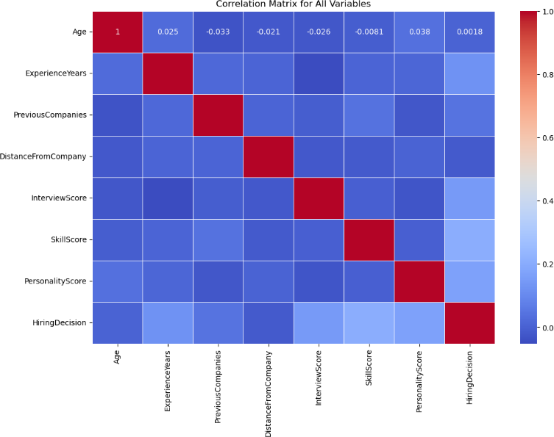Figure 1 presents the correlation heatmap for the dataset’s features. SkillScore, PersonalityScore and InterviewScore have the highest positive correlation with the target feature, HiringDecision, indicating that higher scores in these areas are associated with a higher likelihood of a positive hiring decision.

Fig. 1 Correlation Heatmap

### Gender Distribution in the Dataset

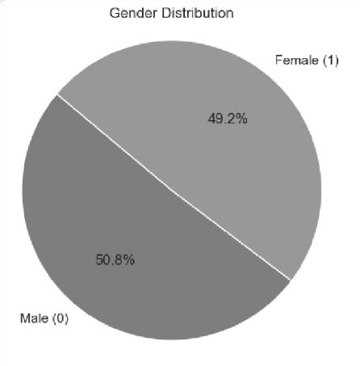Figure 2 shows a near-equal gender distribution in the dataset, with males comprising 50.8% of the data and females making up 49.2%. This balanced gender representation is important for ensuring fairness in predictive modeling and reducing gender biases in hiring predictions.

Fig. 2 Gender Distribution

### Education Level Distribution in the Dataset

Figure 3 shows the number of candidates by education level. The majority, around 740 candidates, have a Bachelor's (Type 2) degree. Master's degrees are held by 317 candidates, while 307 candidates have a Bachelor's (Type 1) degree. The least common are PhD holders, with approximately 136 candidates, indicating fewer highly specialized individuals.

Fig. 3 Education Level Distribution

### Recruitment Strategy Distribution in the Dataset

Figure 4 displays the distribution of different recruitment strategies used in the dataset. The "Moderate" strategy is the most prevalent, applied to approximately 770 candidates, indicating a balanced approach that weighs both candidate potential and organizational requirements. The "Aggressive" strategy, implemented for around 450 candidates, suggests a more proactive hiring approach, likely prioritizing rapid talent acquisition to meet urgent workforce demands. In contrast, the "Conservative" strategy, used for roughly 280 candidates, reflects a more selective hiring process, potentially favoring highly qualified or specialized candidates. This distribution highlights a clear preference for a balanced hiring approach over extreme selectivity, suggesting that organizations aim to optimize efficiency while maintaining a thorough evaluation process. The varied use of strategies may also indicate differences in hiring needs across job roles, industries, or company cultures.

Fig. 4 Recruitment Strategy Distribution

## Machine Learning Models

To ensure a thorough evaluation of the factors influencing hiring decisions, this study employed a range of machine learning algorithms. These models were selected for their ability to handle complex, structured datasets and to mitigate overfitting, as follows:

### Random Forest (RF): To Random Forest was chosen for its robustness in handling high-dimensional data and its ability to mitigate overfitting by averaging multiple decision trees. It is particularly useful in handling complex relationships between features and can provide feature importance rankings [11].

### Support Vector Machine (SVM): SVM was employed to test the model's ability to classify candidates based on a linear or non-linear decision boundary. SVM is well-suited for datasets where the decision boundary is not easily separable and can perform well with high-dimensional data.

### Logistic Regression (LR): Logistic Regression was used as a baseline model due to its simplicity and interpretability. As a linear classifier, LR serves as a useful benchmark to compare the performance of more complex models in binary classification tasks.

### Gradient Boosting Algorithms (XGBoost, LightGBM, CatBoost): These ensemble methods were included due to their strong predictive power and efficiency in handling large datasets. Gradient boosting algorithms iteratively improve model predictions by correcting errors from previous iterations. XGBoost, LightGBM, and CatBoost were specifically chosen for their ability to handle imbalanced data and capture complex non-linear relationships [12][13].

The models were evaluated based on accuracy, precision, recall, F1-score, and AUC-ROC. These metrics help assess model performance from both an overall accuracy and class- specific perspective, which is crucial in the context of imbalanced datasets where class distribution may not be uniform.

# A graph of a chart Description automatically generated with medium confidenceResults

## Model Accuracy Scores

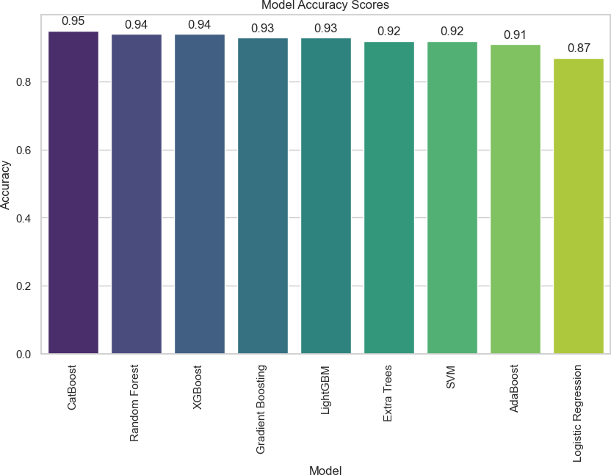Figure 5 presents the accuracy scores across all models evaluated in this study. CatBoost outperforms the other models with an accuracy of 95%, closely followed by Random Forest and XGBoost, both of which exhibit accuracy scores around 94%. In contrast, Logistic Regression shows the lowest accuracy, highlighting its limitations for this dataset.

Fig. 5 Histogram of Model Accuracy Scores

## Model Comparison & Evaluation

### 1) CatBoost: Table III. shows the classification report for CatBoost. This model achieves impressive results with a high precision of 0.96 for class 0 (Not Hired) and 0.93 for class 1 (Hired). The recall for class 1 (0.91) and class 0 (0.97) suggests that CatBoost performs well in both identifying hires and non- hires, with an overall accuracy of 0.95.

1. classification report for catboost

|  |  |  |  |  |
| --- | --- | --- | --- | --- |
|  | **Precision** | **Recall** | **F1 Score** | **Support** |
| **Class 0** | 0.96 | 0.97 | 0.97 | 215 |
| **Class 1** | 0.93 | 0.91 | 0.92 | 85 |
| **Accuracy** |  |  | 0.95 | 300 |

### 2) Random Forest: Table IV. shows the classification report for Random Forest. The model exhibits a high precision of 0.95 for class 0 and 0.94 for class 1, but the recall for class 1 is slightly lower (0.86), suggesting it may miss some hires. Despite this, it maintains an accuracy of 0.94, indicating strong overall performance.

1. classification report for random forest

|  |  |  |  |  |
| --- | --- | --- | --- | --- |
|  | **Precision** | **Recall** | **F1 Score** | **Support** |
| **Class 0** | 0.95 | 0.98 | 0.96 | 215 |
| **Class 1** | 0.94 | 0.86 | 0.90 | 85 |
| **Accuracy** |  |  | 0.94 | 300 |

### 3) XGBoost: Table V. shows the classification report for XGBoost. This model exhibits strong precision and recall for class 0 (0.95 and 0.96, respectively). However, its performance for class 1 (hired) is slightly lower with precision of 0.90 and recall of 0.88, suggesting it may miss more positive instances. Nevertheless, its overall accuracy remains 0.94.

1. classification report for xgboost

|  |  |  |  |  |
| --- | --- | --- | --- | --- |
|  | **Precision** | **Recall** | **F1 Score** | **Support** |
| **Class 0** | 0.95 | 0.98 | 0.96 | 215 |
| **Class 1** | 0.94 | 0.86 | 0.90 | 85 |
| **Accuracy** |  |  | 0.94 | 300 |

## ROC-AUC Curves

Figure 6 displays the ROC-AUC curves for all models. CatBoost, with the highest ROC-AUC score of 0.9292, demonstrates superior performance in distinguishing between hired and non-hired candidates. Random Forest follows closely, achieving an AUC of 0.9309. XGBoost, while still strong, has a slightly lower ROC-AUC score of 0.9262. The ROC-AUC curve provides a more nuanced evaluation of model performance, particularly when the dataset is imbalanced.

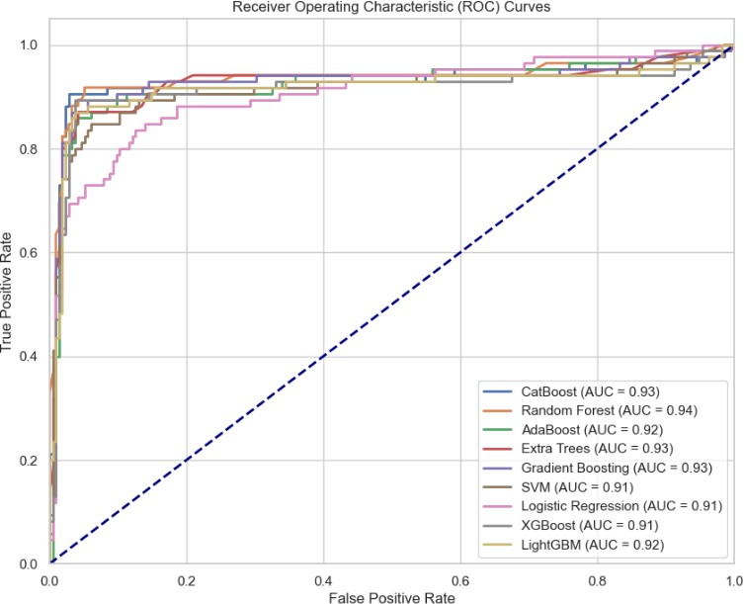

### 

Fig. 6 ROC Curves for all models

## Hyperparameter Tuning

Hyperparameter tuning was performed using GridSearchCV and RandomSearchCV to optimize model performance. Table VI. summarizes the results before and after tuning for all four models. CatBoost and XGBoost showed stable performance after tuning, indicating their default parameters were well-suited for this dataset. Random Forest exhibited a slight decrease in accuracy, suggesting limited gains from tuning.

1. model accuracy after hyperparameter tuning

|  |  |  |  |
| --- | --- | --- | --- |
| **Model** | **Before Tuning** | **After Tuning (GridSearchCV)** | **After Tuning (Random Search)** |
| **CatBoost** | 0.9533 | 0.9542 | 0.9542 |
| **XGBoost** | 0.9400 | 0.9292 | 0.9292 |
| **Random Forest** | 0.9400 | 0.9242 | 0.9225 |
| **Logistic Regression** | 0.8667 | 0.8657 | 0.8558 |

# Discussion

## Model Accuracy Scores

CatBoost achieves the highest accuracy of approximately 95%, outperforming Random Forest and XGBoost, which exhibit accuracy scores of 94%. Logistic Regression shows the lowest accuracy, confirming that more complex models perform better for this dataset, particularly when capturing non-linear relationships.

## Model Comparison & Evaluation

CatBoost is the most effective model, balancing precision and recall well, with a strong F1-Score indicating reliable performance for both hires and non-hires. Random Forest has strong precision for class 0 but lower recall for class 1, potentially missing some hires. XGBoost performs well overall but also has lower recall for class 1. While CatBoost is the best based on accuracy and F1-Score, all three models are viable depending on the importance of precision versus recall in hiring. The implementation of K-Fold Cross-Validation with K=30 strengthened the credibility of the results by ensuring that each candidate was used multiple times across different training and validation sets, leading to a more stable and reliable model evaluation.

## ROC-AUC Curves

The ROC-AUC scores provide a better understanding of model performance beyond accuracy. CatBoost leads with the highest AUC, followed by Random Forest and XGBoost, demonstrating that these models are quite capable of distinguishing between hires and non-hires. The AUC scores further confirm that all three models are well-suited for the task of predicting hiring outcomes.

## Hyperparameter Tuning

The stability of CatBoost and XGBoost after tuning demonstrates their robustness, making them reliable options for recruitment predictions. In contrast, the sensitivity of Random Forest to parameter changes highlights the need for careful tuning to avoid overfitting.

## Feature Importance

In all three models, RecruitmentStrategy is identified as the most important feature in predicting hiring outcomes. This is not surprising, as the recruitment strategy likely encompasses critical factors such as the methods and channels through which candidates are sourced. EducationLevel and PersonalityScore are also crucial features, indicating that both academic qualifications and personal traits play an important role in predicting hiring success. Interestingly, Random Forest places more importance on SkillScore and PersonalityScore, suggesting a model preference for assessing personal qualities alongside educational background and experience.

## Challenges Faced

### High Accuracy Scores: With models like CatBoost, Random Forest, and XGBoost all showing high accuracy, it becomes difficult to choose the best performer. To address this, evaluating additional metrics such as F1-Score, recall, and ROC-AUC is crucial. In scenarios with imbalanced data, precision and recall become particularly important for balancing the trade-offs between false positives and false negatives.

### Hyperparameter Tuning: Hyperparameter tuning is a critical but time-consuming process. While automated techniques like GridSearchCV and RandomSearchCV offer solutions, they can still be computationally expensive and time- consuming for complex models.

## Real World Implications

### Streamlined Recruitment: Using machine learning models can significantly reduce time and costs in recruitment processes. By automating tasks such as resume screening, the model helps HR professionals focus on more strategic and value-added activities.

### Bias Reduction: The model's data-driven approach can minimize human biases, leading to more equitable hiring decisions. By evaluating candidates based on objective criteria like experience and skills, the model can promote diversity and inclusion within the workplace.

### Enhanced Decision-Making: Insights from the model can help HR professionals refine their recruitment strategies and identify candidates more likely to succeed in their roles. The ability to make evidence-based decisions can improve hiring outcomes and align the recruitment process with organizational goals.

## Limitations of the Study

The study's dataset is relatively small (1,500 candidates), which may limit the generalizability of the findings. Furthermore, it relies primarily on demographic and qualification-based features, potentially overlooking other factors like cultural fit or soft skills, which may influence real- world hiring decisions. The black-box nature of machine learning models, particularly in terms of interpretability, could be a challenge for HR professionals who seek to understand and trust model predictions fully [13]. Finally, despite efforts to mitigate bias, the use of historical data means the model could unintentionally perpetuate past biases present in the hiring process.

##### Conclusion

This study identified CatBoost as the top-performing model, achieving 95% accuracy with balanced precision and recall for both non-hires and hires, making it the most effective at identifying candidates across all categories. Random Forest and XGBoost also demonstrated strong performance but showed a slight bias toward the majority class, indicating areas for improvement in identifying minority class instances. Among the evaluated features, Recruitment Strategy emerged as the most influential predictor of hiring outcomes, followed by Education Level and Personality Score. These findings highlight the importance of strategic recruitment methods, formal education, and personal traits in driving hiring success.

The study also found that hyperparameter tuning had minimal impact on CatBoost’s performance, demonstrating its robustness and stability for this dataset, while slight improvements were observed for Random Forest and XGBoost. Overall, the results emphasize the potential of machine learning models, particularly CatBoost, to enhance recruitment processes by automating hiring decisions, reducing bias, and promoting fairness. These insights can help HR professionals make data-driven decisions, streamline recruitment workflows, and implement strategies that foster diversity and improve hiring efficiency [15].

##### Areas For Future Research & Improvements

Future research should explore additional machine learning algorithms and ensemble methods, including deep learning, to improve prediction accuracy and handle complex data. Expanding feature engineering to include new candidate attributes, such as social media activity or psychometric assessments, can enhance predictive power. Addressing biases with fairness-aware techniques will ensure equitable treatment and support diversity. Real-world validation through practical recruitment scenarios is crucial to assessing the model's impact on efficiency and diversity. Furthermore, enhancing model interpretability is essential to make machine learning models more transparent and trustworthy for HR professionals. Using larger and more diverse datasets will also improve the generalizability of the findings and ensure the models are robust across different contexts [16].

##### References

1. Kalusivalingam, A. K., Sharma, A., Patel, N., & Singh, V. (2020). Optimizing Workforce Planning with AI: Leveraging Machine Learning Algorithms and Predictive Analytics for Enhanced Decision-Making. *International Journal of AI and ML*, *1*(3).
2. Smith, A., Johnson, T., & Lee, M. (2022). Bias and fairness in predictive hiring models: A review of current approaches. *Journal of Artificial Intelligence Research*.
3. Uppal, A., Awasthi, Y., & Srivastava, A. (2024). Machine learning-based approaches for enhancing human resourcemanagement using automated employee performance prediction systems. *International Journal of Organizational Analysis*.
4. Begum, S. A., Nammalwar, S., Vijayalakshmi, J., & Vallabha, M. (2024, July). Predictive HR: Ensemble & Deep Learning Methods for Strategic Employee Retention. In *2024 Third International Conference on Electrical, Electronics, Information and Communication Technologies (ICEEICT)* (pp. 1-6). IEEE.
5. Hossain, M. S., Hossain, M. R., Hasan, S. M., Akter, F., Srizon, A. Y., Faruk, M. F., & Islam, H. (2023, December). Leveraging AI-Driven Strategies to Mitigate Employee Turnover in Commercial Industries. In *2023 26th International Conference on Computer and Information Technology (ICCIT)* (pp. 1-6). IEEE.
6. Liu, X., Chen, Y., & Zhang, H. (2024). Ensemble learning techniques for predictive hiring: A comparative study of traditional and advanced models. *Proceedings of the IEEE Conference on Machine Learning and Applications*.
7. Jones, D., & Patel, R. (2023). The role of machine learning in modern recruitment: Challenges and opportunities. *International Journal of Data Science and Analytics*.
8. Tasheva, S., & Karpovich, A. (2024). *AI-driven recruitment: Balancing efficiency and human values in the age of automation*. Journal of Human Resource Management, 12(3), 45-60*.*
9. Al-Quhfa, F., Al-Mansoori, S., & Al-Hammadi, T. (2024). *A comparative analysis of machine learning models in talent recruitment within business intelligence systems*. International Journal of Business Intelligence and Data Mining, 19(2), 210-225.
10. Peña, A., Serna, I., Morales, A., Fierrez, J., Ortega, A., Herrarte, A., Alcantara, M., & Ortega-Garcia, J. (2023). *Human-centric multimodal machine learning: Recent advances and testbed on AI-based recruitment*. Journal of Artificial Intelligence Research, 68, 123-145..
11. Breiman, L. (2001). Random forests. Machine learning, 45, 5-32.
12. Chen, T., & Guestrin, C. (2016). XGBoost: A scalable tree boosting system.
13. Friedman, J. H. (2001). Greedy function approximation: A gradient boosting machine. Annals of Statistics, 29(5), 1189-1232
14. Suresh, H., & Guttag, J. V. (2021). A framework for understanding unintended consequences of machine learning. Communications of the ACM, 64(11), 62-71
15. Canaan T. Madongo, Zhongjun Tang, and Jahanzeb Hassan, "A Cross-Modal Transformer Based Model for Box-office Revenue Prediction," Journal of Advances in Information Technology, Vol. 15, No. 7, pp. 822-837, 2024.
16. Vassiliki Papadouli, Elias Houstis, and Manolis Vavalis, "Bankruptcy Prediction of Greek Small and Medium-Sized Enterprises Using Imbalance Data," Journal of Advances in Information Technology, Vol. 15, No. 8, pp. 956-964, 2024.